The Deeper Life Coffers Fellowship (DLCF) WhatsApp Group Chat Analysis

We live in a data driven-world_ ours is a society that's growing in heavy reliance on data, big data and the technical know-how that powers the algorithms of these gadgets, electronic devices and tools we use in our daily lives and interactions.

The Deeper Life Coppers Fellowship is not just a melting pot where intellectuals ranging from varying backgrounds and ethnic milieu cohere via the agency of the cross_ but also, a wonderful spiritual home_ where lives are molded, shaped and set on the trajectory of success, and global reckoning.

Coming from a different denomination, and serving in a state other than mine was really enriching. I found warm embrace, Christ-like models among this amazing platoon in the Lord's Army and joining them during the duration of a one-year mandatory national service was indeed a life-enhancing decision_ it was at the DLCF ( Rivers State chapter) I met visionary souls that impacted my life positively and set on the path of becoming a data analyst/business analyst was birthed.

It was a year of learning, growing and becoming a better version of oneself.

In the month of December 2022, I decided to further hone my skills by running a WhatsApp Group Chat Analysis _ the attached picture gives some details about it.

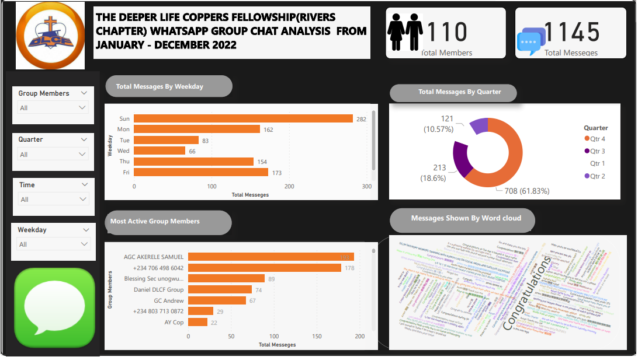

* Time Frame; Jan to December2020.
* Tool: Power Bi
* Vote of Thanks: my sincere appreciation goes to Mr. Bolaji Bi who gave the source code to clean the raw data exported from the group_ and the guidance for its parameters.
* Project Description:

A WhatsApp Group Chat analysis using Power

Project Process:

* Data Collection:

The first step in doing any work is getting the required data sets_ either by web crapping, downloading/extracting already stored data sets in the cloud or company's database. For our WhatsApp Group Chat Analysis_ our data sets will be gotten via exported the non-media data of the aforementioned group. One must ensure permission is gotten before undertaking such_ for security and privacy purposes.

* Data Transformation:

After our data has been exported successfully in its raw form as in txt format_ its indeed a dirty data_ one that can qualify for messy data

Data Transformation is very important as real world data sets are messy. In the course of training and learning, one seldom uses dirty data sets_ however, real world data trumps the finicky nature of data one is accustomed to. In bid to transform our data, various tools can be utilized, viz;

* Python
* R
* Alteryx
* Power Query (Tool embedded in Excel, power Bi and few Microsoft products).
* Sales force (Data prep)
* IBM Cognos etc.

Ours, is the Power Bi (power query engine) that helps data analysts transform messy data sets into their desired/required data format. Since, our exported data sets was messy_ Power query's M code would be deployed to clean the raw data. The source code for the cleaning_ would be used thus;

* Open a blank query and paste the code.
* Rename the query to your desired name.

After this has been done successfully, one need to create a custom function that will be used on the imported data in power query engine.

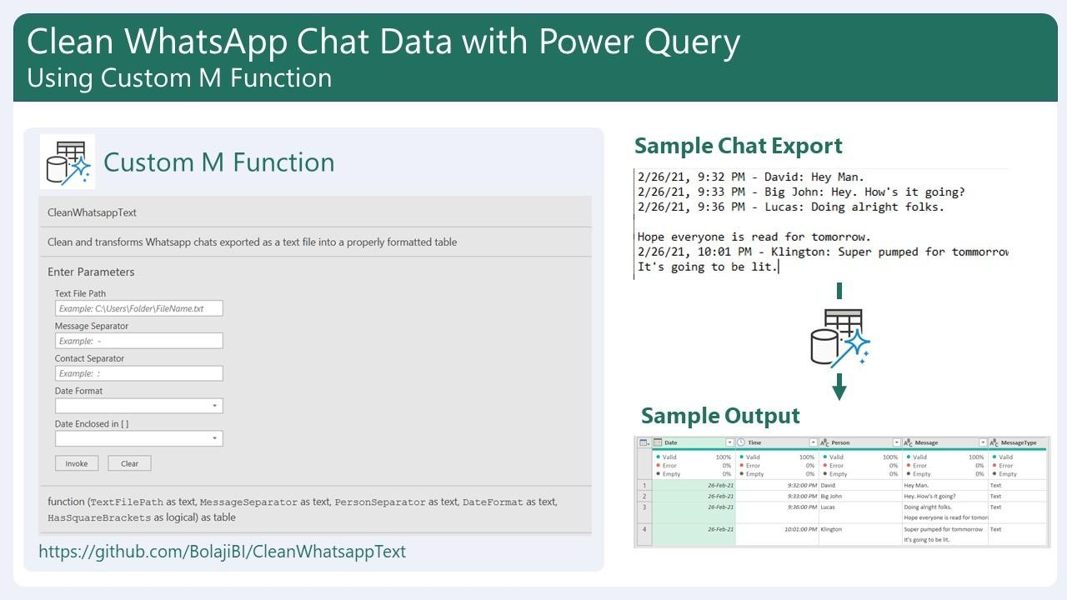In creating the custom function, some parameters/fields are required before its can be prep for usage_ they're thus;

Source: image as provided by Bolaji Bi Parameters

* TextFilePath - This is the file path of the exported chat on your PC.
* Message Separator - This is the character separating the actual message sent from the DateTime info from the Contact's Name. In the sample image above, this is a hyphen (-).
* Contact Separator - This is the character separating the Contact's Name (Person) from the actual message sent. In the sample image above, this a colon (:).
* Date Format - This an option to select whether the date format in the exported file is "DD/MM/YYYY" or "MM/DD/YYYY". In the sample image above, this is "MM/DD/YYYY". This is option is necessary because, based on feedback, the date format of the exported chats tends to differ by device type and region settings.
* Date Enclosed in [ ] - This a TRUE or FALSE option to specify whether the DateTime info from the exported chats are enclosed in square brackets. This option is necessary because, based on feedback, exports from iPhone devices seem to have the DateTime part enclosed in square brackets while export from Android devices do not. For example, the sample image above is based on an Android device. For data exported via an iPhone, one may get this; "[2/26/2021, 9:32 PM] David: Hey Man". In that iPhone sample, Message Separator would be a space ( ); Contact Separator would be a colon (:); Date Format would be MM/DD/YYYY; and Date Enclosed in [ ] would be TRUE.

NB: for an Android phone/device_ Date Enclosed in [ ] would be FALSE, whereas that of an iPhone would be TRUE.

Project Walkthrough:

After our data has been transformed_ we can then load into the power Bi Desktop _ by hitting the load and apply button. We then have to write two DAX measures to get the total number of members and total number of sent messages in our data. After this is done, we then create a custom date function that includes: WEEKDAY, DAY to enable us capture details of events that transpired during particular weekdays and day. After working out the DAX aspect, we then build our Dashboard based on varying requirements or specifics that suits us.

NB: building a design layout in the power Bi report is very possible_ the only drawback is that its makes the model slow and bad for performance.

Results;

* From the analysis, it was discovered that the total number of sent messages stood at: 1145, while total number of members in the group was: 110
* Sunday was the most active day in the lives of the group members, it accounted for 282 messages in the overall messages sent to the group, followed by Saturday with a count of messages at: 225
* The 4th Quarter of last year took the lion share out of the entire quarters of the year, as it had over 61.83% out of the total messages sent to the group.
* AGC Akerele Samuel, +2347064986042, Blessing Sec Unogwu, Daniel DLCF Group and GC Andrew were the most active members of the group.
* 9.00pm was the peak time, when the most number of messages dropped.
* Congratulations, Deeper life Christian Ministry Monday Bible Study outline, DLCM Saturday Workers Training with kumuyi Live on Social Media and Satellite locations ranked among the most used words/clauses in the group.